Ashley McTee
English 2010-054
Group 9
Review

Healthcare Reform: The Good, the Bad and the Ugly

Abstract

This review will provide information regarding the good, the bad and the ugly parts of the new Healthcare Reform that was signed by President Obama in 2010. This information will show what is in store for the general public when it comes to their healthcare.

The Good
The Healthcare Reform Bill was signed by President Obama on March 23, 2010 and since has provided some good aspects for the general public regarding healthcare. So far more Americans have been able to obtain insurance coverage because of the insurance premiums decreasing as well as allowing their children to stay on their insurance until the age of 26.
With the increase in people seeking coverage due to lower insurance premiums they have noticed that they are not being excluded for coverage due to a pre-existing medical condition. This as well as not being dropped from their current insurance plan due to getting sick was all due to the new Healthcare Reform Act.
New healthcare plans will cover the cost of an annual wellness visit in full that way the patients aren’t paying out of pocket for just a general checkup. Also, the Healthcare Reform will expand Medicare out to rural urban areas of the United States to assist the lower income families obtain healthcare coverage.

The Bad

Implementing anything new for an entire country will cost a lot. With the new healthcare reform being implemented over the next few years and fully in effect by 2014 it has stirred up some issues when it comes to people money (Figure 1). Americans are worried that implementing the new reform will increase the taxes that are taken out of their income.
Also, they are worried that if they do not obtain healthcare insurance they will have to pay a yearly fine of $695 a year and it is subject to change. Now that doesn’t sound like it will do any good for the general public, it seems it does more harm that anything.
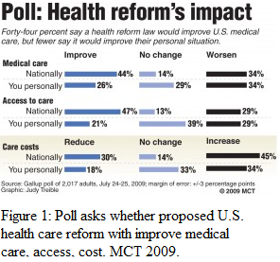

The Ugly

Many American’s do not agree with the new healthcare reform. They believe that the government has not right to force them to get insurance and some even say is unconstitutional. The Constitution states that we have a right to life, but it doesn’t say that the government has the right to make that choice for us. Benjamin Franklin said “They, who can give up essential liberty to obtain a little temporary safety, deserve neither liberty nor safety.” To give the government control on your healthcare can mean that they choose whether you live or die.
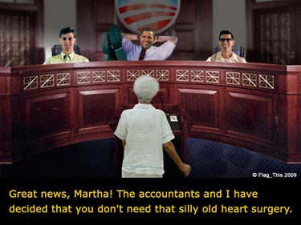
Under the new healthcare reform it provides the government the choice to decide whether a person is able to receive treatment or not, whether they should be kept on life support, ect. In some cases people call the situation of government controls on life, death panels because it is left in the government, not the individual person or their family on whether a person lives or dies.

Conclusion

In conclusion it seems that the new Healthcare Reform will cause more harm to America. There are still ongoing changes to the healthcare reform as well as new lawsuits against it, so who knows it may not stay in place very long, but they do need to find some sort of way to help improve the healthcare coverage in American.
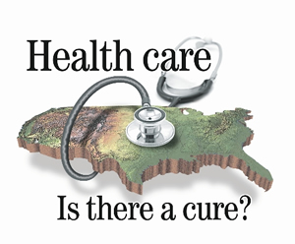

Works Cited

Lightman, David. "Which Tax Should Rise to Pay for Health Care Overhaul? Which Tax Should
Rise to Pay for Health Care Overhaul? McClatchy Newspapers, 19 Aug. 2009. Web. 9
Mar. 2012. <http://www.dailytitan.com/2009/08/which-tax-should-rise-to-pay-for-
health-care-overhaul/>.
Lipana, Josh. "A Medical Doctor Explains the Pros and Cons of ObamaCare." Capitalism
Magazine. Josh Lipana, 2 Oct. 2010. Web. 9 Mar. 2012.
"Read the Law." Home. U.S. Department of Health & Human Services. Web. 9 Mar. 2012.
<http://www.healthcare.gov/law/full/index.html>.
South, Mark. "Obama Health Care." Obama Health Care. 5 Apr. 2010. Web. 9 Mar. 2012.
<http://www.obama-health-care.org/>.
"Top 10 Pros & Cons - Health Care Reform - ProCon.org." Health Care Reform ProCon.org. 1
Sept. 2010. Web. 9 Mar. 2012. <http://healthcarereform.procon.org/view.resource.php?resourceID=003725

